

**SECP1513-07 TECHNOLOGY AND INFORMATION SYSTEM**

**Design Thinking Project Report**

**Product Name: Campus Bus Tracking Application**

**Group Members:**

1. Ang Hui Shan A25CS0192
2. Gan Luo Xi A25CS0224
3. Tan Jia Qi A25CS0358
4. Teo Ying Ling A25CS0149
5. Tor Si Jie A25CS0369

Prepare for: Dr. Suriati binti Sadimon

# TABLE OF CONTENTS

1. Introduction 1
   1. What is Design Thinking? 1
2. Detail Step 3
3. Detailed Description 6
   1. Problem 6
   2. Solution 6
   3. Team Working 7
4. Design Thinking Assessment 8
5. Design Thinking Evidence 8
   1. Empathize phase 8
   2. Define phase 13
   3. Ideate phase 20
   4. Prototype phase 21
   5. Test phase 24
6. Reflection 25
7. Task Distribution 28
8. Reference 28

# ​1.0 Introduction

# 1.1WHAT IS DESIGN THINKING?

Design thinking is an approach to problem-solving and innovation focused on human- centered design. It focuses on understanding people’s needs and then generating creative ideas to solve the problem. There are 5 phases of design thinking , namely Empathize, Define,

Ideate, Prototype and Test .

## Phase 1. Empathize

During this stage, the designer tries to discard their notions and learn more about the users. This is paying attention to and conversing with others to gain a deeper understanding of their thoughts and how they interact with. To develop user empathy, you conduct surveys, interviews, and observation sessions. These help to get to know the human need for which you are designing.

## Phase 2: Define

In the define phase, the information gathered during the empathize stage is analyzed and synthesized to clearly define the core problem. This phase focuses on creating a clear, user- centered problem statement that guides the design process. The key here is to frame the problem from the point of view of your user, and not as what the company needs. Define it as ‘what they need’, and not ‘what you need to do’.

## Phase 3: Ideate

In ideate stage, designers generate a wide range of creative ideas and possible solutions to the defined problem. This phase encourages open thinking and innovation without immediately judging or eliminating ideas. It helps to explore different angles and think beyond unconventional methods. By the end of the brainstorming process, you’ll have a short list of possible ideas to proceed with.

## Phase 4: Prototype

In the prototype phase, designers create simple and low-cost models . A prototype is a reduced version of the product that includes the possible solutions that were found in earlier stages. This step is important for testing each solution and finding any problems or limitations before developing a final product.

## Phase 5: Test

In the testing phase, the prototypes are evaluated by real users to gather feedback and measure how well the solution addresses the problem. The feedback obtained is used to refine the design, and the process may be repeated to improve the solution further, before investing resources into the development of your solution.

# 2.0 DETAIL STEPS

This project is based on the theme of Big Data and Artificial Intelligence Innovation, focusing on solving real problems faced by university students. After group discussions, we identified issues related to campus transportation, particularly the lack of real-time information, unclear bus schedules, and poor communication during delays or cancellations. These challenges often cause inconvenience and wasted time for students. To address this, we proposed the development of a Campus Bus Tracking Application integrated with an AI Chatbot, aimed at improving efficiency, accessibility, and user experience for all students, including those who are visually impaired.

## Empathize

To understand users’ needs, we examined the daily experiences of students who frequently use campus bus services. Many students shared frustrations about not knowing when the bus would arrive, whether the bus was overcrowded, or if services were delayed. We conducted an online survey to collect students’ opinions and observed student behavior at bus stops during peak hours. These activities helped us better understand the impact of unreliable transportation information on students’ schedules and overall campus life.

## Define

After analyzing the survey results and observations, we identified the main problems faced by campus bus users. These include unclear bus arrival times, lack of information on bus crowd levels, and delayed or missing notifications when buses are cancelled or delayed. These findings highlighted the need for a system that can deliver accurate, real-time updates and effective communication

Table: Key Problems Identified

|  |  |
| --- | --- |
| **No.** | **Identified Problems** |
| **1** | Unclear bus arrival times |
| **2** | No information on bus crowd levels |
| **3** | Late or missing delay notifications |

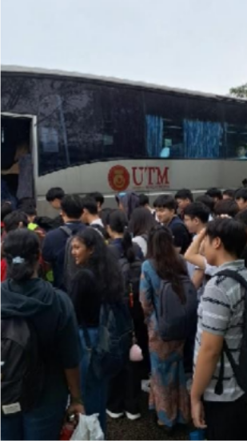

*Figure 1:Students are overcrowded at the bus stop*

**

*Figure 2:The bus was abruptly cancelled* [*https://share.google/images/ri0jviGG0dhKsk1uc*](https://share.google/images/ri0jviGG0dhKsk1uc)



*Figure 3:Overcrowding of students on the bus* [*https://share.google/images/n5DUf3FbKsnD9Whqb*](https://share.google/images/n5DUf3FbKsnD9Whqb)

## Ideate

During the ideation stage, our group brainstormed multiple solutions to solve the identified problems. The ideas included GPS-based real-time tracking, trip planning features, automated notifications, and the use of data to estimate bus crowd levels. We also proposed integrating an AI chatbot to help users quickly access information and support accessibility through voice interaction. After evaluating the feasibility and effectiveness of each idea, we selected the development of a campus bus tracking application with AI chatbot support as the most suitable solution.

## Prototype

Based on the selected solution, we designed a prototype using Canva. The prototype focuses on a simple and user-friendly interface that allows users to plan trips, search for bus stops, view real- time bus locations, and interact with the AI chatbot. Accessibility features such as voice input and output were included to ensure the application can be used by visually impaired users.

Throughout the prototyping process, the design was refined to ensure it met user needs and addressed the identified problems.

## Test

After completing the prototype, we invited several students to test the application. Users were asked to perform tasks such as checking bus arrival times, viewing crowd levels, and using the AI chatbot. We observed their interactions and collected feedback through short discussions. The feedback helped identify areas for improvement, such as improving notification clarity and enhancing chatbot response accuracy.

# DETAIL DESCRIPTION

## Problem

In many university campuses, students frequently arrive late to class due to inefficiencies in the campus bus transportation system. At UTM campus, although buses operate on fixed routes and schedules, students often are unable to obtain accurate and real-time information regarding bus operations.

One major issue is the absence of a tracking system that provides real-time bus location and estimated time of arrival (ETA). As a result, students must estimate the bus arrival time by themselves, which increases the risk of missing the bus. This problem becomes more severe during unexpected situations such as bad weather, traffic congestion, bus breakdowns, car accidents, or delays. In some cases, buses may also arrive earlier than scheduled or be too full to take additional passengers, further increasing uncertainty.

Additionally, many students, especially new students, are unfamiliar with campus bus routes and schedules. They may not know which bus to take or which bus stop they should wait at. The lack of a proper guidance system may cause students to take the wrong bus.

Due to these challenges, students often waste time waiting at bus stops, miss buses, take inefficient routes, or arrive late for class. Therefore, a reliable and real-time campus bus tracking solution is required to improve punctuality and enhance the overall campus transportation experience.

## Solution

To address the issue of students arriving late due to the lack of reliable bus information, our team developed a **Campus Bus Tracking Application enhanced with AI-powered features.** The system aims to provide **accurate, real-time, and personalized information** to help students make better travel decisions within the campus.

The system is designed with several features to support students. First, students are able to **plan their trips** by searching for bus stops and viewing available routes and schedules. Once the trip begins, **real-time tracking** allows students to monitor the distance of the bus and its estimated arrival time. To further support decision-making, the system also displays the **crowded level of each bus**, helping students avoid waiting for buses that are already full.

To handle unpredictable situations such as traffic accidents, bus breakdowns, or traffic congestion, the system actively communicates with users through **notifications**. Students are immediately informed when a bus is delayed, arrives earlier than expected, or becomes unavailable, allowing them to adjust their travel plans in advance.

Beyond basic tracking, the system provides an **AI chatbot assistant** that further simplifies access to information. Instead of navigating through multiple screens, students can ask natural questions about bus location and arrival time. The chatbot also supports accessibility features, making the system usable for **visually impaired users.**

In addition, the system allows **bus drivers** to update bus status directly through the application. Drivers can report delays or cancel services during emergencies or bus breakdowns, ensuring that accurate information is instantly reflected in the system and shared with students.

## Team working

The project was carried out through continuous discussion and coordination among all team members. At the early stage, we explored different ideas and agreed on the overall direction of the system. Decisions were made collectively, and adjustments were discussed whenever improvements were needed. Each member contributed to the project in a different way. **Luo Xi** worked on the introduction and edited the report to maintain consistency in writing. **Teo** focused on documenting the development process and preparing assessment-related content. **Hui Shan** described the system details and explained how the proposed solution works. **Si Jie** collected supporting evidence and online references to strengthen the justification of the system. **Jia Qi** managed task allocation and developed the prototype to demonstrate the functionality of the application. Communication was mainly done through online platforms, where ideas, feedback, and progress updates were shared regularly. Information gathered from discussions and research was gradually refined and incorporated into the report. By combining individual contributions and maintaining active communication, the team was able to complete the project with a clear structure and a well-developed prototype.

# DESIGN THINKING ASSESSMENT POINTS

During the empathize stage, user needs and challenges were explored through surveys and direct observation. In the define stage, the collected data was analyzed to clearly identify key problems faced by campus bus users. During the ideate stage, various solutions were proposed and evaluated before selecting the most effective option. In the prototype stage, a functional prototype was developed using Canva to demonstrate the proposed solution. Finally, in the testing stage, user feedback was gathered and evaluated to further refine and improve the system.

# DESIGN THINKING EVIDENCE RECORD FOR EACH PHASE

## 5.1 EMPATHY PHASE

We conducted a survey using Google Form to access users’ background, experience and also opinions regarding our idea of the campus bus tracking app.

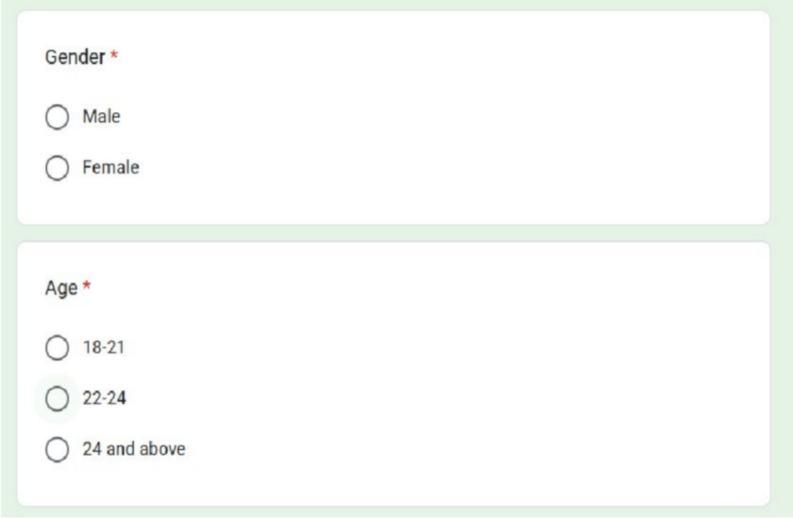**Background**

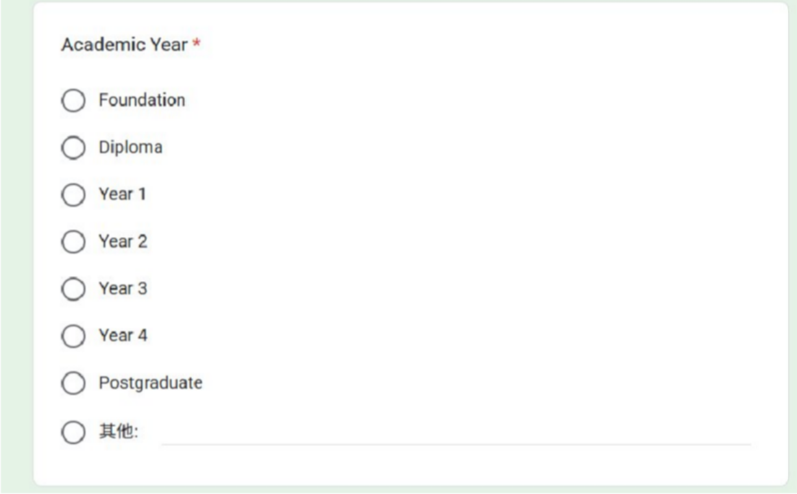

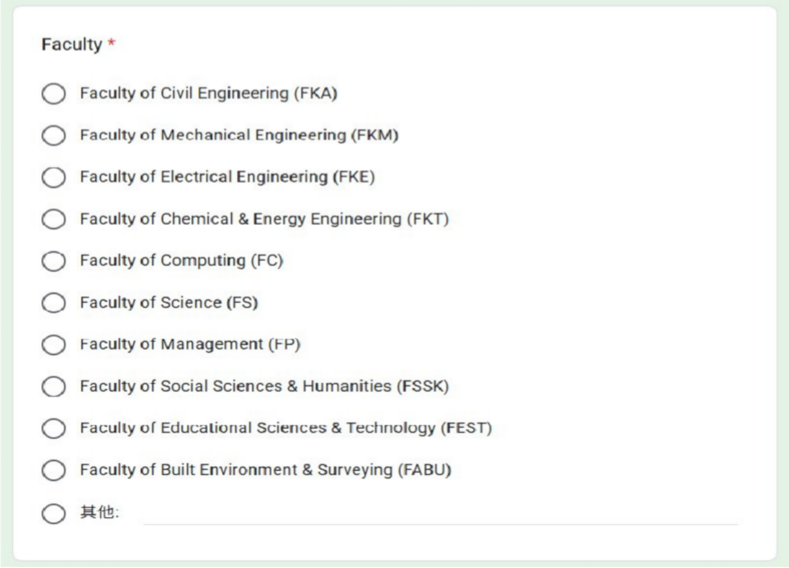

**Experience**

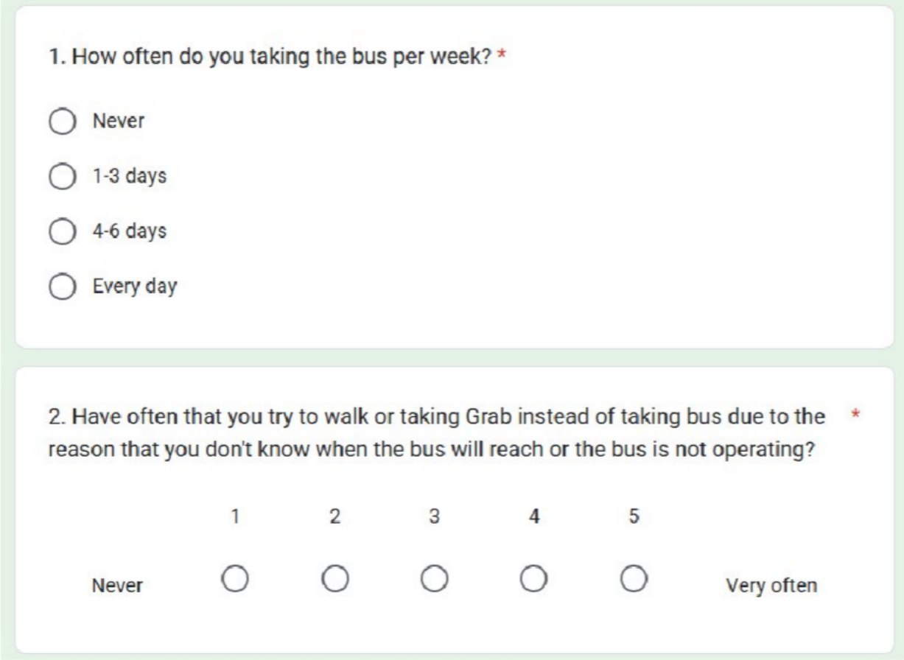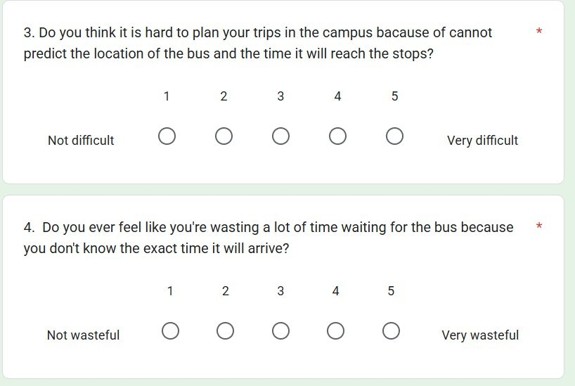

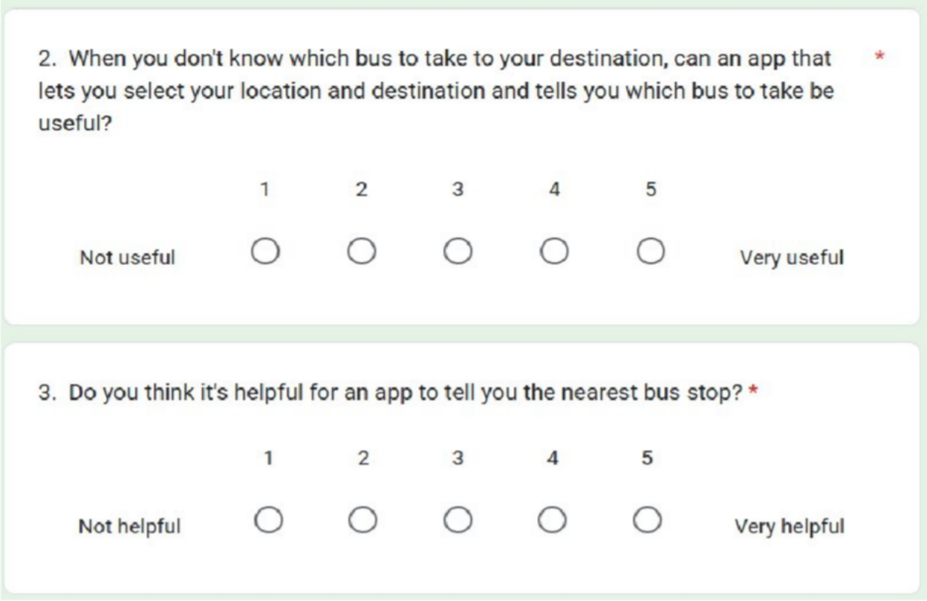

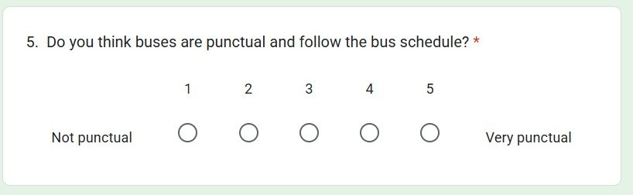

**Opinions and Suggestions**

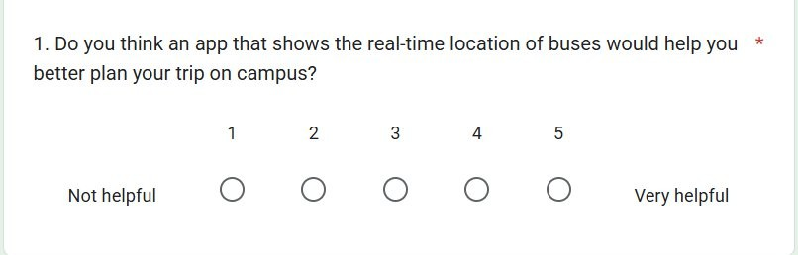

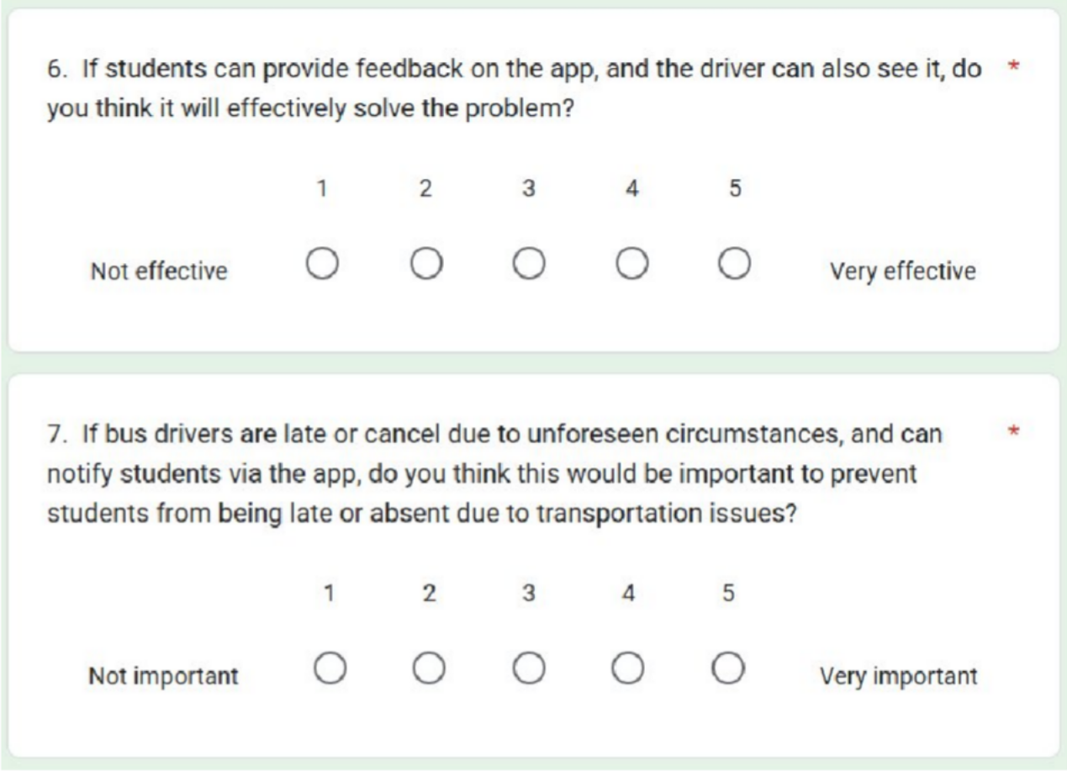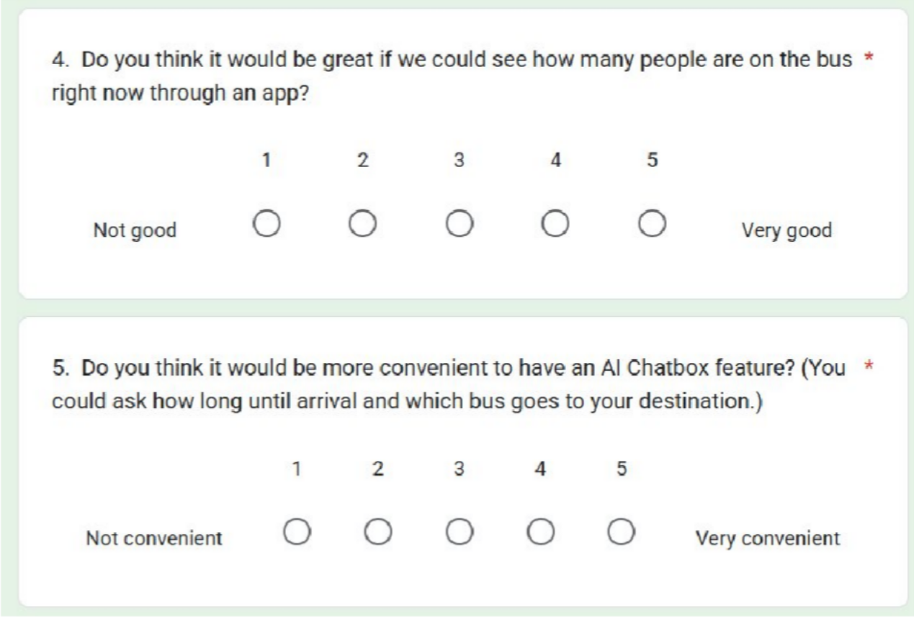

## 5.2 DEFINE PHASE

In this phase, we collected the information and analysed the data from the survey forms to identify the problems that faced by users when they are taking the campus bus and also get their opinions on our campus bus tracking app.

**Background 1.GENDER**

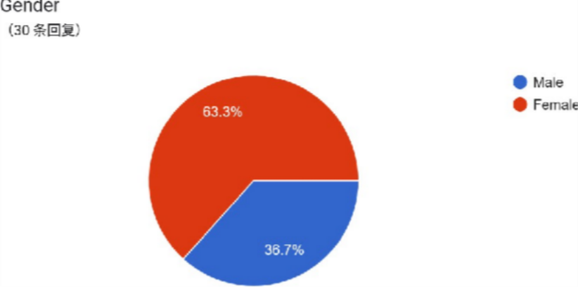

**2.AGE**

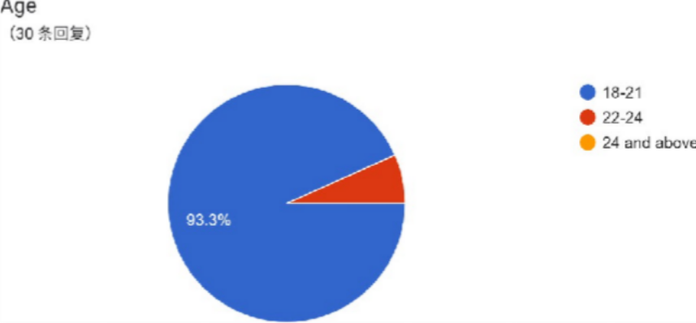

1. **ACADEMIC YEAR**

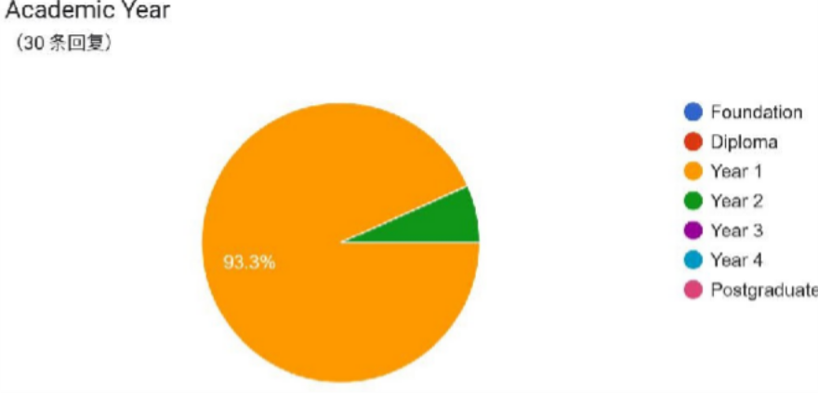

1. **Faculty**

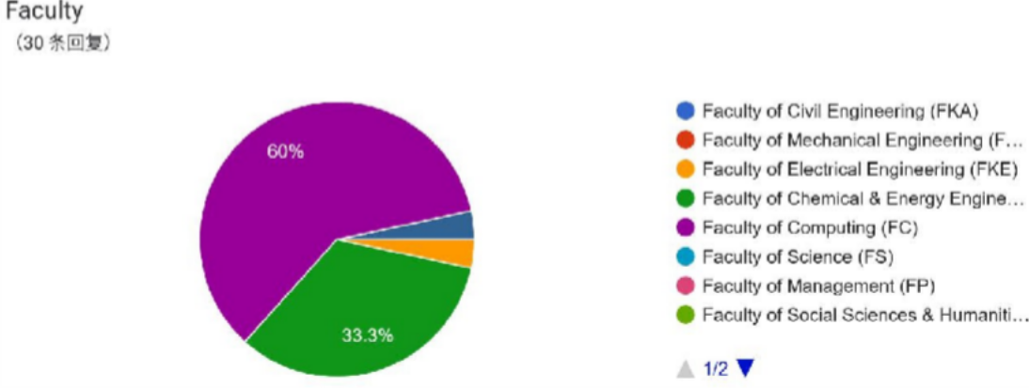

**Experience**

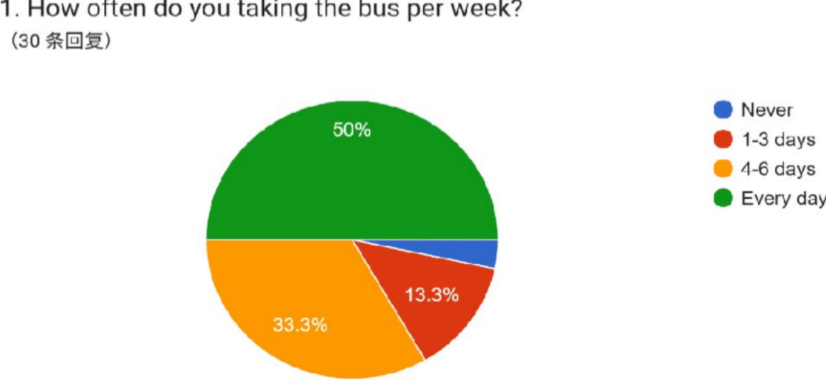

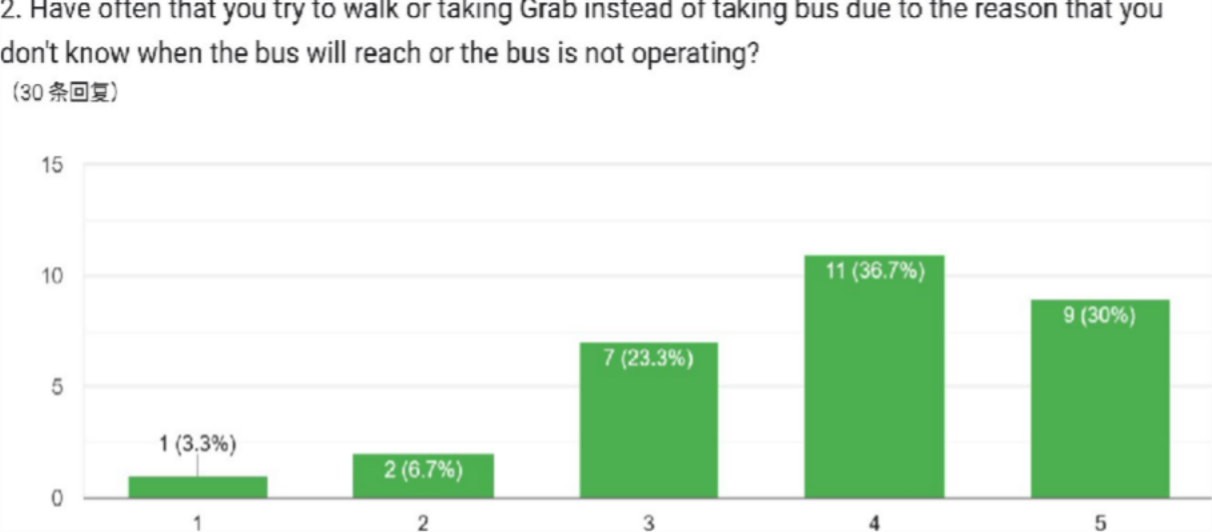

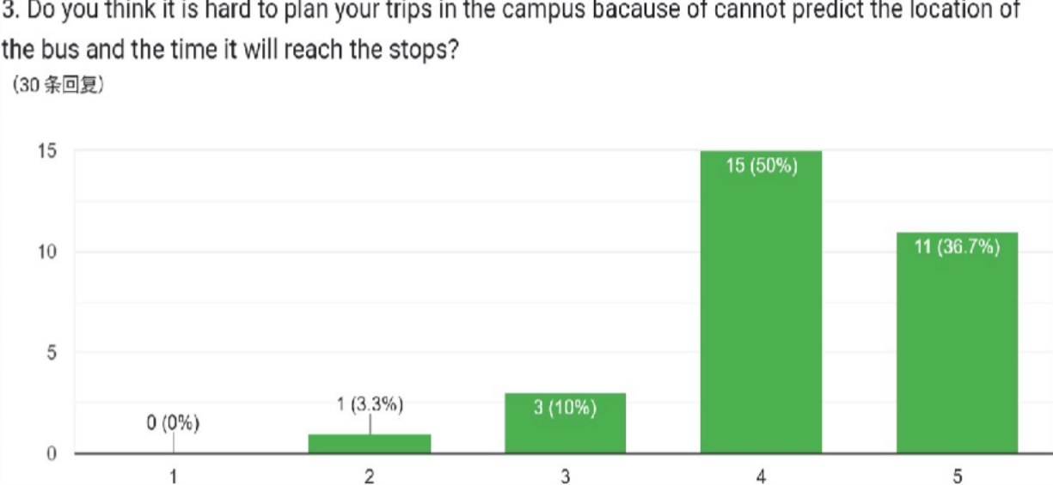

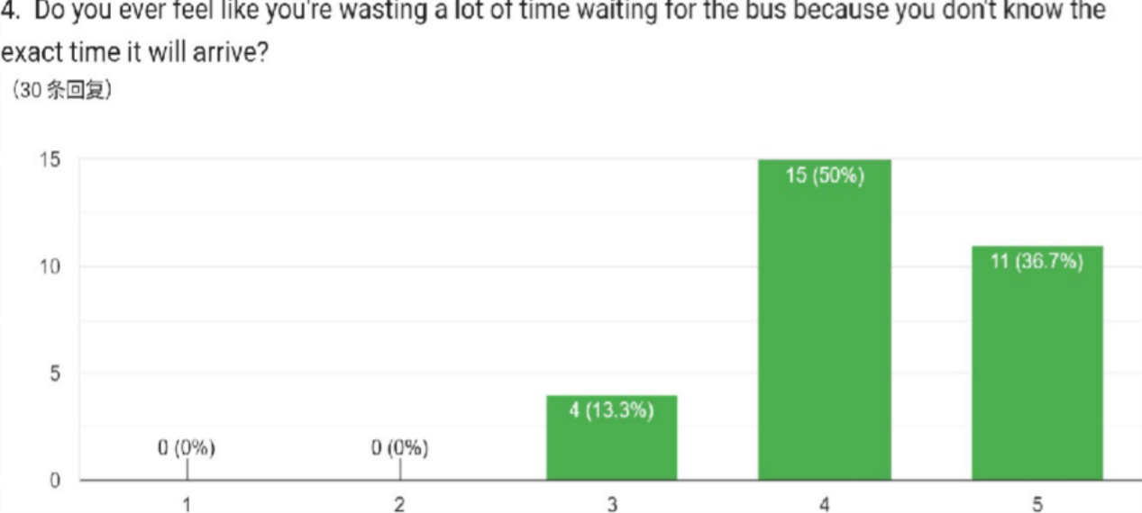

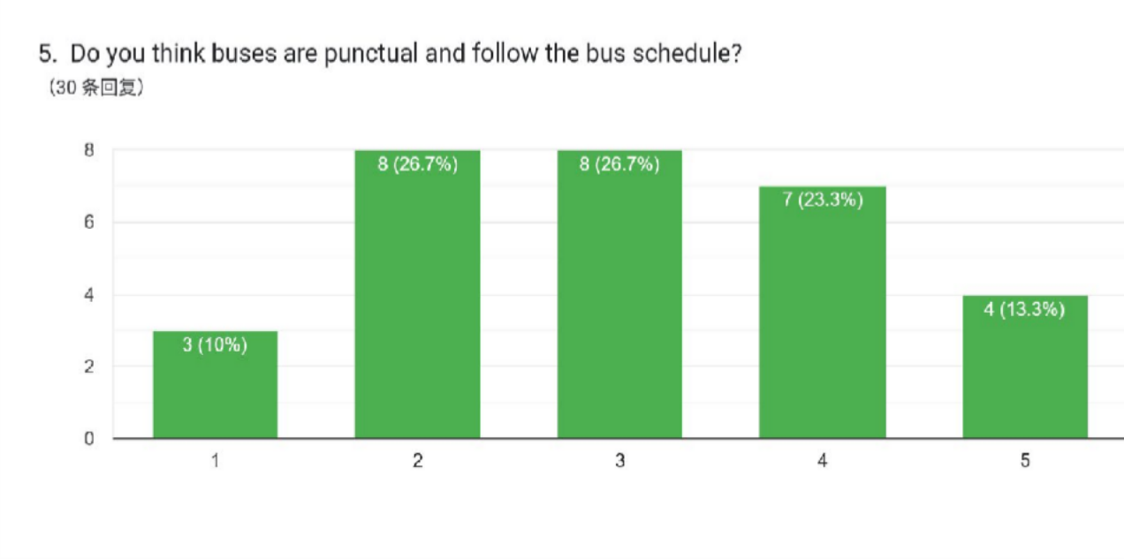

Not punctual

Very punctual

**Suggestions and Opinions**

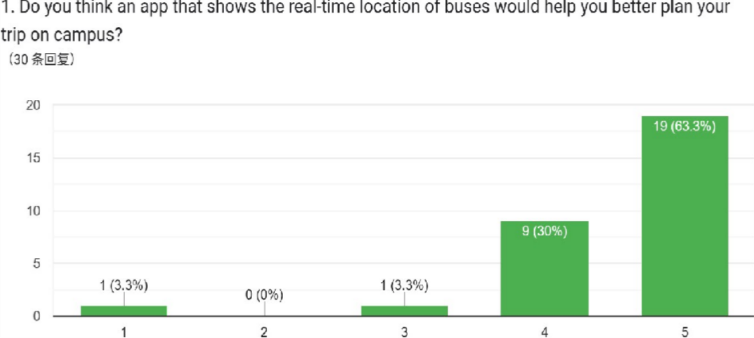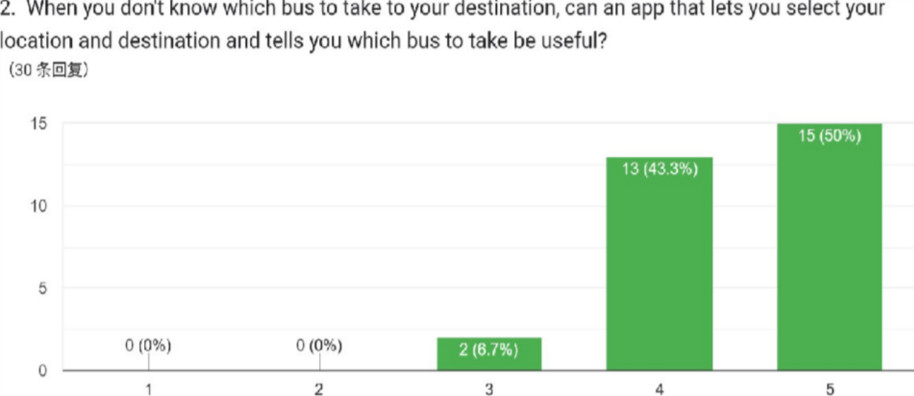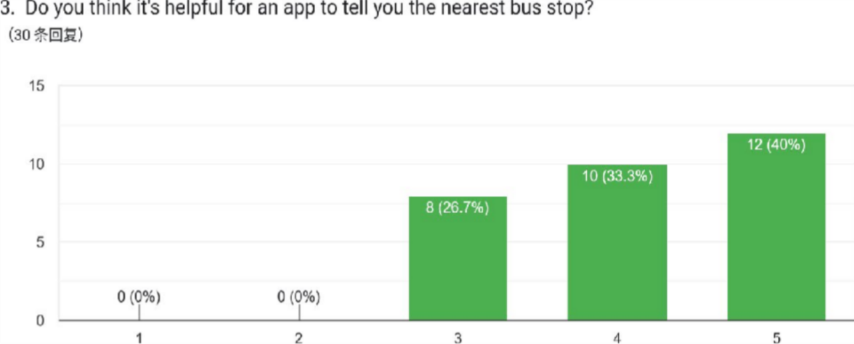

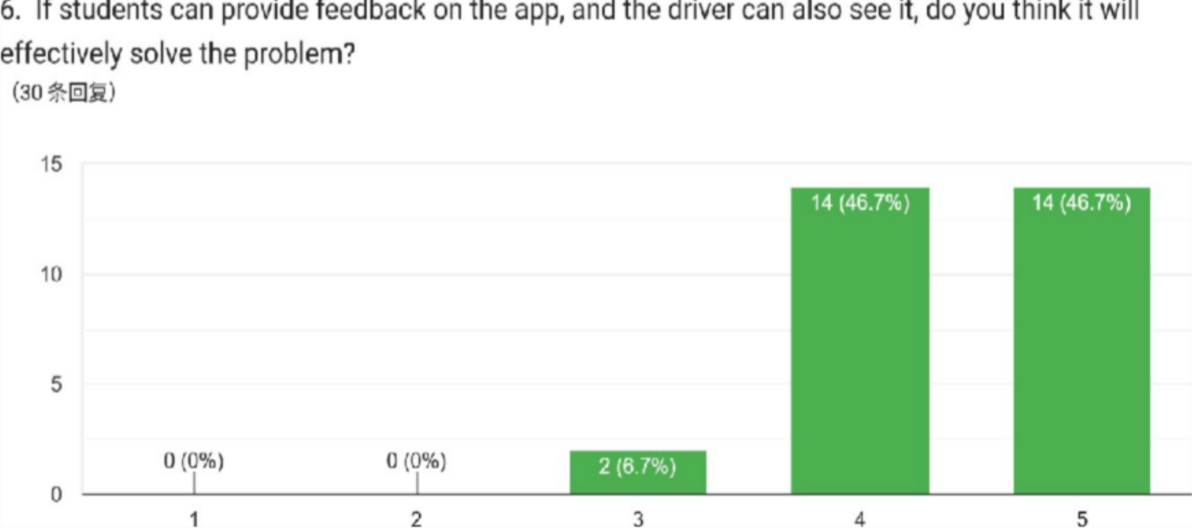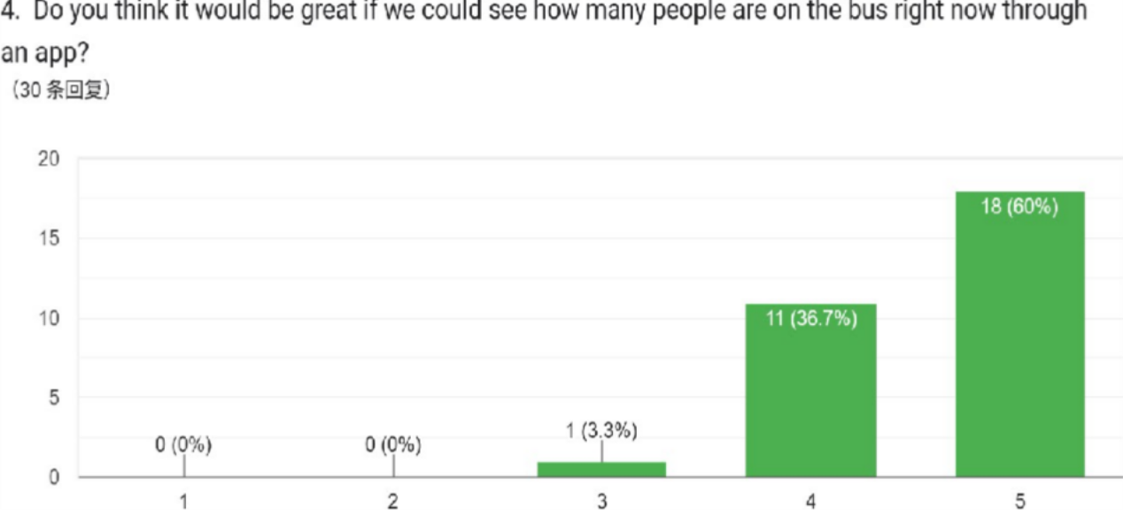

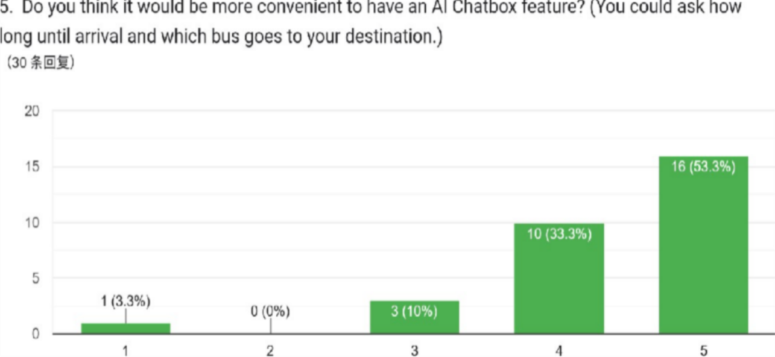

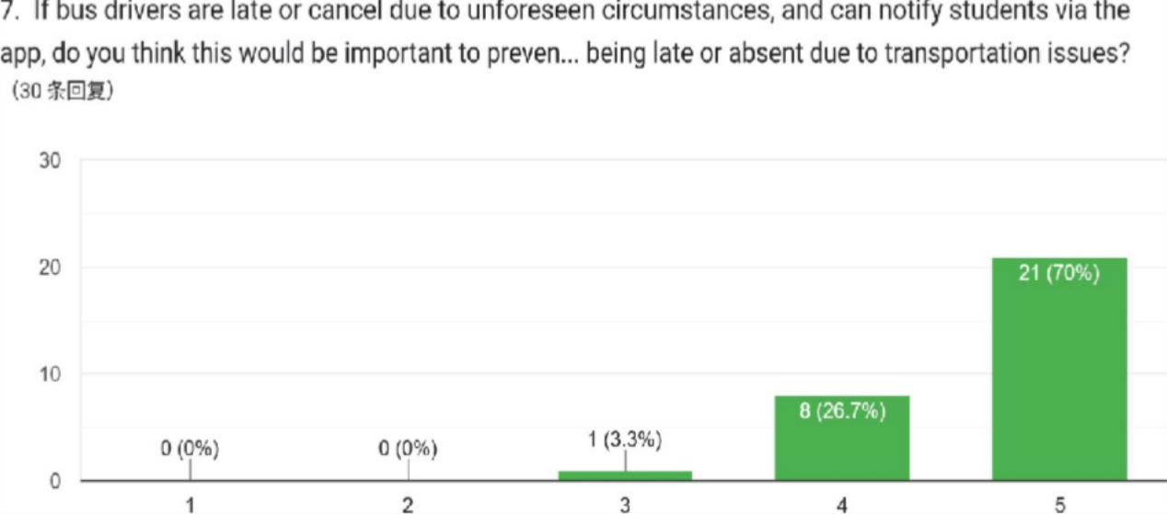

## 5.3 IDEATE PHASE

We conducted several discussions to identify the problems and also suggested the solutions to solve the problems. After the brainstorming sessions, we analysed and chose the best solutions for developing our campus bus tracking app.

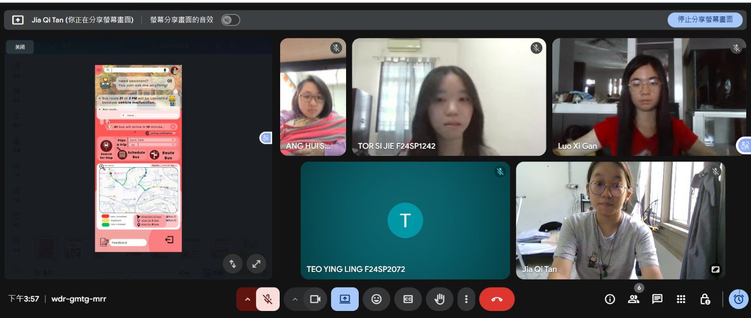

## 5.4 PROTOTYPE PHASE

We designed a prototype which can solve the problems faced by users when they taking the campus bus using the data collected from the survey forms.

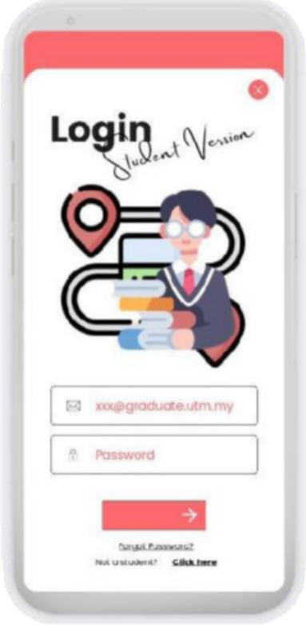2

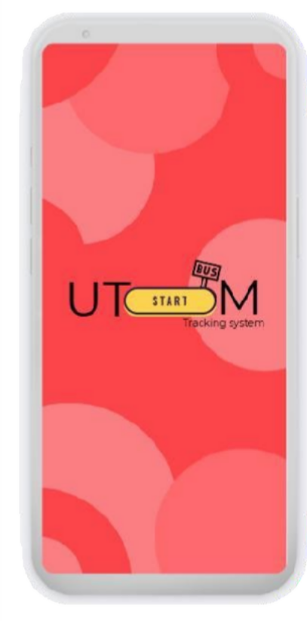

1

3 4

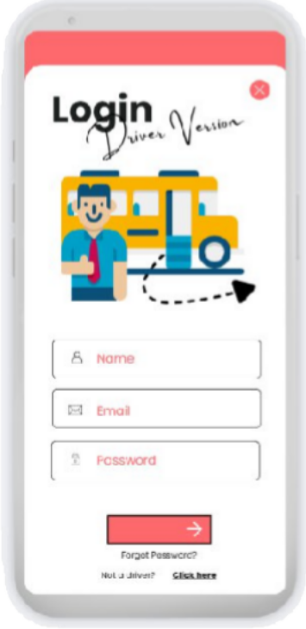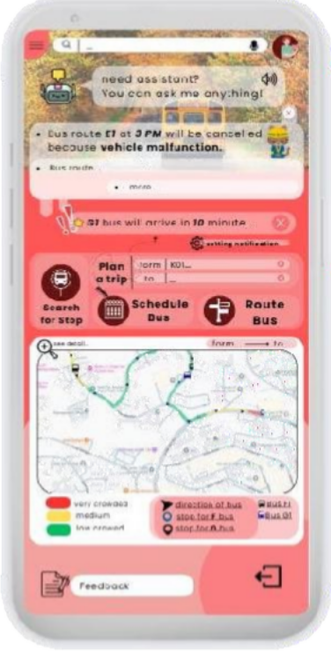

5 6

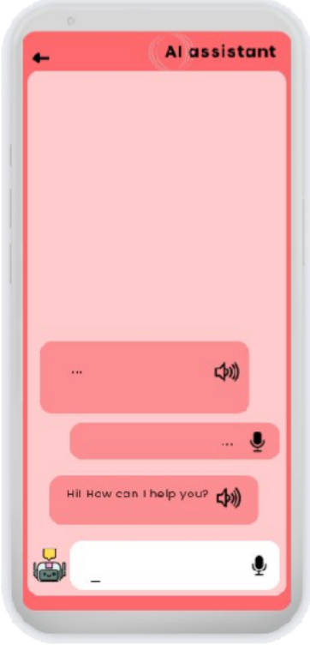 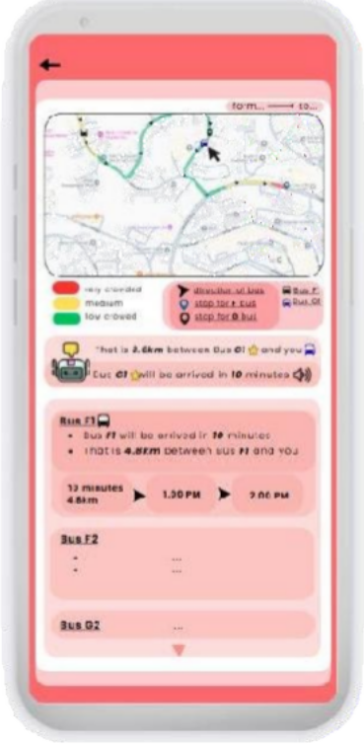

7 8

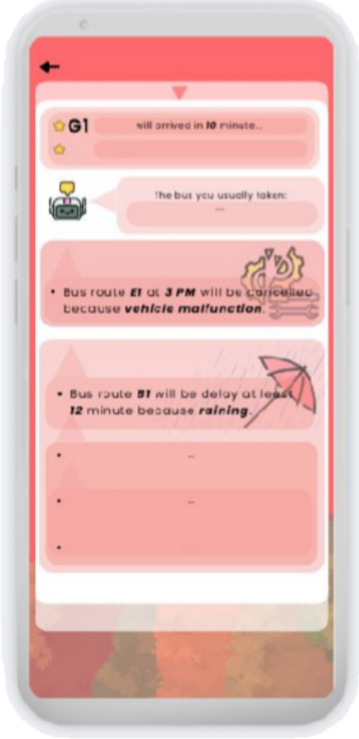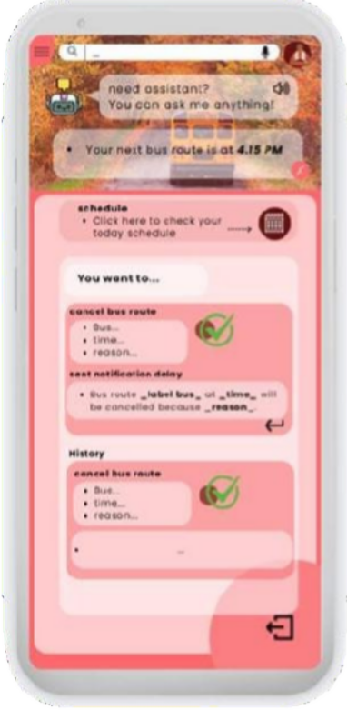

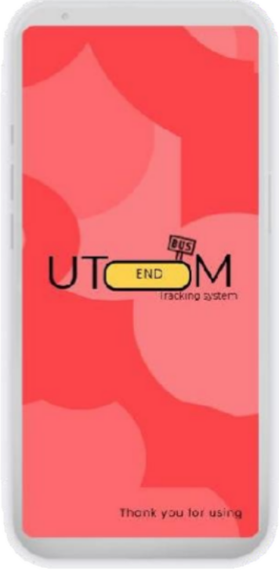9

## 5.5 TESTING PHASE

We observed the users when they are interacting with our prototypes and get the feedback from them to know if there are any shortcomings. The feedback enables us to refine the solutions and improve the functionality.

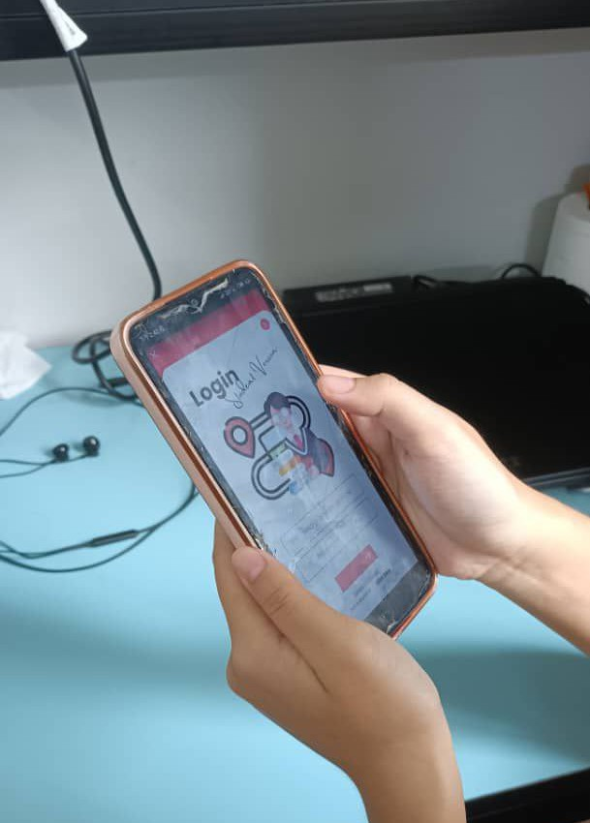

# 6.0 REFLECTION

# i.TAN JIA QI (A25CS0358)

## What is your goal/dream with regard to your course/program?

-My goal with regard to my course is to deepen my understanding of computer science and to acquire more programming knowledge. I hope that through this learning, I can become talent in my practical skills in programming, problem-solving, and system development. This will enable me to solve real-world programming problems more efficiently and reliably. Hence, I will continue to improve my technical skills during my university years.

## How does this design thinking impact on your goal/dream with regard to your program?

-Design thinking helps me gain a deeper understanding of user needs. By following the design thinking process, I can critically think and realize the ways to solve real-world problems step- by-step. These are not only aesthetically pleasing but also practical and user-friendly. I believe this will be an invaluable experience in my future job and projects. It helps improve my problem-solving, creativity, and ability to clearly explain project details to users.

## What is the action/improvement/plan necessary for you to improve your potential in the industry?

**-** To improve my potential, I should improve my programming skills through self-learning, attending workshops, and joining programming competitions to understand where I need to strengthen my abilities and exchange experiences with other professionals. In addition, I must improve communication, teamwork, and presentation skills to communicate more effectively.

I should also gain a better understanding of future technological trends

# TEO YING LING (A25CS0149)

## What is your goal/dream with regard to your course/program?

My goal is to become a creative and skilled professional in the field of Computer Science with a focus on Graphic and Multimedia. I aim to combine technical programming skills with graphic design and multimedia production to develop innovative digital applications, interactive media, and creative AI-based solutions. I dream of working in industries where I can create user-friendly, visually appealing, and functional software that enhances user experience and solves real-world problems.

## How does this design thinking impact on your goal/dream with regard to your program?

Learning and applying Design Thinking has given me a structured approach to problem- solving, which is very relevant to my course. By empathizing with users, defining problems, ideating solutions, prototyping, and testing, I can better understand user needs and create multimedia applications that are both functional and user-friendly. This process encourages creativity, critical thinking, and innovation, which are essential skills in the graphic and

multimedia industry. It also shows me how to integrate technology and design effectively to meet user expectations.

## What is the action/improvement/plan necessary for you to improve your potential in the industry?

To improve my potential in the industry, I plan to practice and improve my programming and multimedia design skills, apply Design Thinking in real projects to better understand user needs, follow the latest trends and technologies in graphic and multimedia, and create a portfolio of creative projects that showcase both my technical and design abilities.

# GAN LUO XI (A25CS0224)

## What is your goal/dream with regard to your course/program?

My goal with regard to my course is to gain strong knowledge and practical programming skills that can be applied to real-world problems. I hope to perform well in my studies and prepare myself for a successful and stable career in the future.

## How does this design thinking impact on your goal/dream with regard to your program?

Design thinking helps me approach problems from the user’s perspective rather than focusing only on technical aspects. It improves my ability to design software solutions that are practical, user-friendly, and innovative, which is important for my future career in IT.

## What is the action/improvement/plan necessary for you to improve your potential in the industry?

To improve my potential in the industry, I need to continuously improve my programming skills, practice problem-solving, and gain hands-on experience through projects and internships. I also plan to improve my communication skills and stay updated with current technologies.

# TOR SI JIE(A25CS0369)

## What is your goal/dream with regard to your course/program?

My goal in studying my course is to become a software developer who can create useful and attractive applications. I want to use my programming and design skills to build systems that can help people in their daily lives. In the future, I hope to work in the technology industry and be involved in real software development projects.

## How does this design thinking impact on your goal/dream with regard to your program?

This design thinking project helped me understand how to solve real problems using

technology. I learned that identifying the problems and understanding user needs is very important before designing a solution. This project also improved my skills in UI design, system planning and problem-solving. It helped me connect what I learn in the class to real- world applications and supports my goal of becoming a software developer.

## What is the action/improvement/plan necessary for you to improve your potential in the industry?

To improve my potential in the industry, I plan to further enhance my programming and design skills by learning more about mobile application development, UI/UX design principles, and real-time data integration. I also need to build more practical projects, participate in internships, and stay updated with current industry technologies. Besides, I need to improve my problem- solving skills and communication skills. This is because it is important in the teamwork. All of these will help me become more industry-ready and confident in contributing to real software development projects.

# ANG HUI SHAN (A25CS0192)

## What is your goal/dream with regard to your course/program?

My goal in Technology and Information System program is to develop strong technical skills that relevant to game development. I aim to understand how systems, software and digital technologies can be optimized to create interactive experiences. In future , I hope I can apply all the knowledge that I learned to work in a game development company.

## How does design thinking impact your goal/dream with regard to your program?

Design thinking help to identifies and solve problems in creative way, which essential for game development. By empathizing with users, define problem, and exploring solutions, I can design games that are enjoyable and functional.

## What is the action/improvement/plan necessary for you to improve your potential in the industry?

In order to improve my potential, I plan to strength my practical and language skills. I will keep learning different programming language such as C++, Python and C#. I also plan to participate in workshops, online course to gain hands-on experience.

# 7.0 THE TASK FOR EACH MEMBER

|  |  |  |  |  |  |
| --- | --- | --- | --- | --- | --- |
| **NAME**  **TASK** | **GAN LUO XI** | **TOR SI JIE** | **TEO YING LING** | **TAN JIA QI** | **ANG HUI SHAN** |
| **Report** | Introduction, Editing Report | Design Thinking Evidence, Make and conclude the result form Google Form | Detail Step and Descriptions, Design Thinking Assessment | The Task for Each Member, Produce and testing Phototype | Detailed Description |
| **Video** | Recorded video, edit video | | | | |
| **Slide** | Make presentation slide | | | | |
| Discussion of project, Presentation and Reflection | | | | | |

# 8.0 Reference

1**.** Tuttle, G. (2021, February 24). *What is design thinking and why is it important?* WeWork Ideas. [https://www.wework.com/ideas/professional-development/creativity-culture/what-is-design-thinking](https://www.wework.com/ideas/professional-development/creativity-culture/what-is-design-thinking?utm_source=chatgpt.com)